

SCHOOL *of* BUSINESS AND TECHNOLOGY

Department of Engineering and Aviation Sciences

**The Design of a**

**Smart Fire Detection System**

**Israel Akinsoyinu**

**David Goslee**

**Dedrick McCoy**

Advisor: Dr. Zang

2/24/2019

The Design of a Smart Fire Detection System

By

Israel Akinsoyinu, David Goslee, Dedrick McCoy

Submitted to the Department of Engineering and Aviation Sciences in partial fulfillment of the requirements for the degree of Bachelor of Science in Engineering at the

UNIVERSITY OF MARYLAND EASTERN SHORE

Date: 2/24/2019

The author hereby grants the University of Maryland Eastern Shore permission to reproduce and distribute publicly, paper and or electronic copies of this document in whole or in parts.

Authors Israel Akinsoyinu, David Goslee, Dedrick McCoy

Signature

Date

Department of Engineering and Aviation Sciences

Certified by

**Special notice for formatting for the whole report:**

1. **Keep the formatting consistent (learn and apply the MS ‘Styles’ in formatting). Do not change any format but just apply corresponding styles as listed.**
2. **Do not add any blank rows but use BREAKS, except the end of a table. BREAKS can be found on ‘Page Layout’ → ‘Page Setup’ → ‘Breaks’.**
3. **Every figure or picture must be mentioned in the text first then can appear. When it is mentioned, use the cross-reference.**
4. **Every figure or picture in the text must be accompanied with the caption and detailed description.**
5. **Only third person is allowed (except the Conclusion and Acknowledge sections). Never use ‘we’, ‘our’, ‘you’, etc. anywhere else (use the ‘find’ function of MS Office to double check).**
6. **Use ‘do not’ other than ‘don’t’, and so forth.**
7. **You can copy any reference information from anywhere, but anything not from yourself must be refereed and the original information must be included in the Reference section.**
8. **The reference must be organized with professional software such as ‘Endnote Web’, ‘Mendeley’, etc. Use IEEE reference format.**
9. **Try Grammarly. It can help in fixing typos and grammar errors.**
10. **If you get ‘Styles’ messed up, the easiest way is to start over, to open this blank template and copy-paste contents into it.**

**Table of Contents**

**List of Contents 2**

**List of Figures 4**

**List of Tables 5**

**Abstract 6**

**1.0** **Introduction 7**

**1.1** **Backgound/Motivation 7**

**1.2** **Objective 7**

**1.3** **Design Requirements 7**

**1.4** **Design Constraints 7**

**1.5** **Design Methods 7**

**2.0** **Project Description 9**

**2.1** **System Description 9**

**2.2** **System Diagram 9**

**2.3** **System Functions 9**

**3.0** **Implementation Plan 11**

**3.1** **Tasks 11**

**3.2** **Team Organization 12**

3.2.1. Responsibility of Team Member 1. 12

3.2.2. Responsibility of Team Member 2. 12

**3.3** **Timeline/Milestones/Delivery Plan 12**

**4.0** **Implementation 13**

**4.1** **Implementation of Task 1. 13**

4.1.1. Implementation of Subtask 1.1 13

**4.2** **Implementation of Task 1. 13**

**5.** **Conclusion (Discussion and Future Plans) 14**

**Acknowledgment 15**

**Appendix 16**

**A.** **Component Specs 16**

1. Specs of Arduino Due 16

2. Specs of Raspberry Pi 16

**B.** **Source Code. 16**

1. Source Code of Graphic User Interface 16

2. Source Code of Robotic Arm 16

**REFERENCES 17**

**List of Figures**

Figure 1(b): Fire Detector Mini Project 10

Figure 2(a): Nest Smart Detector and Virtual Display 10

Figure 2(b): Nest Smart Detector 10

Figure 3: One link smart detector 11

Figure 4: Flow Chart 15

Figure 5: Adafruit DHT22 Cirucit Diagram 18

Figure 6(a): First Flying Fish MQ-7 circuit diagram 19

Figure 6(b): Second Flying Fish MQ-7 circuit diagram 19

Figure 7: Flying Fish MQ-2 Circuit Diagram 20

Figure 8: Full alarm circuit layout with all sensors 21

Figure 9: Circuit Diagram for Geekcreit RF transmitter 21

Figure 10: Cirucit Diagram for Geekcreit RF receiver 22

Figure 11: Geekcreit 433 MHz RF transmitter output  23

Figure 12(a): Complete impementation of RF transmitter cirucit 23

Figure 12(b): Complete implementation of RF receiver circuit 23

**List of Tables**

**Abstract**

By the end of the project, summarize the project into short text and put here.

1. **Introduction**

This project will be the design, development, and implementation of a smart fire detection system. This system will utilize modern sensor and network technologies to help notify firefighters and building occupants of an impending or life threatening situation.

## Background/Motivation

This project is the design of a smart fire detection system, with the consideration that there are other systems that already exist. The goal is to make improvements to these devices and add features that set this product apart from the others. With this design the goal is to take out all the issues seen previous systems and to make it user friendly as possible. This will allow individuals to have a thorough understanding of the product and its functions. The design of this product will include a smoke sensor, carbon monoxide sensor, and a temperature sensor. The system will be connected to a webpage that will display the data that is read from each of the sensor nodes in real time. When a problem is detected the webpage will display what the cause of the alarm is and highlight the area of the building in which the problem is located. With this design the plan is to have an SMS message that will inform building occupants and dispatch of what the problem is and where it is located within the building. This will then activate the alarm system and the webpage will display possible escape routes for individuals that are in the structure at that time. This system will be controlled by a Raspberry Pi that will use a built in program call PIVLO that will generate and autonomous phone call to 911 operators that will let them know where the problem is located in the building and the exact nature of the problem at hand. The sensor data will be transmitted via a node network known as a wireless sensor network (WSN). This feature will allow the system to retain its functionality as an alarm based system even if the power is out and there is no WIFI connection.

Upon researching other designs that related to this particular idea, one found an idea for a mini fire detection system on a website called newton projects. It detected potential fire threats using a thermistor, with a simple led that flashes as an alert and a piezo buzzer for the alarm notification. This idea was a great starting point because it presented a good idea but left a lot to be desired. One looked at this mini project and thought of how to make this simple detection system more elaborate and something that can actually serve as a replacement for devices that are already installed.

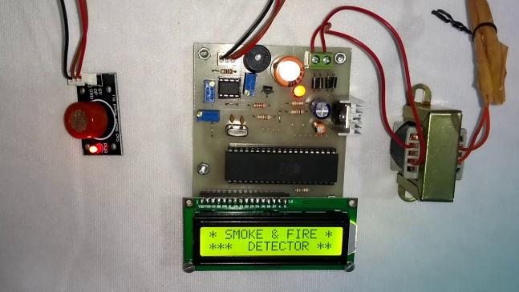      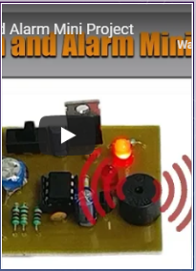

Figure 1(a): Simple Fire Detector Figure 1(b): Fire Detector Mini Project

Upon doing further research one found another system on Amazon called the nest smart detector. This smart detector uses a photoelectric sensor and a split-spectrum sensor to detect potential fire threats. This gave the project team the first idea to use a photoelectric sensor in our earlier design plan, which was later scrapped due to the dramatic increase in the cost of the overall system. The objective of this project is to keep the design within affordable price range. This means that one does not want to exceed the cost of existing detectors on the market. It was found that cheaper sensors exist that offer the same measurement precession for half the price. The Nest smart detector is equipped and offered to customers with its own app, which informs the individual who owns it if a problem is detected. This idea was very interesting and the team decided to add this as a feature for this particular project. However, it was realized that this was actually not needed and in fact was overkill for this particular project. In turn a decision was made to alert occupants in the form of an SMS message. The processes of the SMS message transmission will be done using a software called PLIVO. The nest system had a built in function within the app that allowed the user to shut the detector off in case of a false alarm. With this consideration taken into account it could be something this smart fire detection system could encounter. Thus, an executive decision was made afford the users of this system the ability to turn of the system if a false alarm occurs.

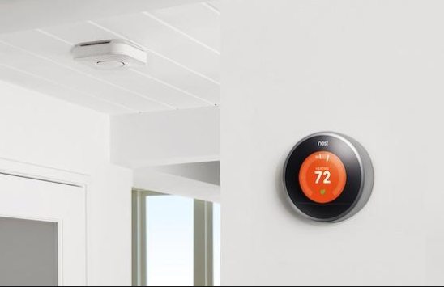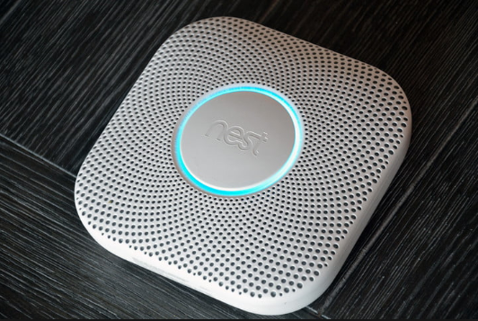

Figure 2(a): Nest Smart Detector and Virtual Display Figure 2(b): Nest Smart Detector

One found another similar system on Amazon. It is the Alexa enabled smoke detector and CO monitor that uses a photoelectric sensor, compatible with both Apple and Android devices. The price range is more excessive than what this project plans to charge. That particular monitor is listed around 180 dollars, where this system will only cost around 100 dollars. This being one of the most expensive systems on the market, one compared this detector to the detector mentioned earlier which was the Nest Smart Detector to find a baseline for the price range of where this product should fall.



Figure 3: One link smart detector

The inspiration behind this project stemmed from the background experience from two of its group members. Two out of the three group members are volunteer firefighters and have direct experience in the field. This led to the thought, what would a first responder want to see and what one believe could make the response time quicker, safer and more efficient. One also employed the ideas of other first responders to see what their thoughts on this device were. This product aims to limit casualties of civilians as well a fellow firemen. One has witnessed casualties caused by flashovers, and other dire situations caused by high temperatures. By having the system relay the temperature to the building occupants and dispatch, the goal is to greatly decrease casualties caused by flashovers. There are many signs of a flashover in which firefighters are thought to be aware of but inevitably due to human error these can be missed. With this product the objective is to have a drastic effect on that. This system will inform dispatch of the location of the threat in the building and floor it is located on. This will afford first responders the ability to pinpoint and isolate their plan of attack without having to assess the situation on scene.

When conducting research on this particular product idea one realized that people often do not have the same reaction to fire alarms, based on the simple premise that they think it is either system testing or a false alarm. This in turn causes individuals to sit idle and wait for the reactions of others. The issue with that particular situation is not the alarm system but the psychological component of the civilians themselves. The plan of this project is to eliminate this component by having a SMS message that will be sent to the occupants of the building. This SMS message will inform the building occupant’s weather or not the alarm is a test or an actual threat. Another hurdle is the problem that can arise when individuals are trying to exit the structure as soon as possible. This project plans to attach this problem by having a website that will show individuals possible escape routes, corresponding to their location within the building. The overall objective of our system is the safety and protection of life for both the civilians and first responders.

Another reason for the creation of this product is one realized the inherent need in fire detection and co monitors, between January 1, 2019 and March 4, 2019 a total of 427 civilian home fire fatalities were reported by the U.S. media, not to mention the fatalities that were not on record. One knows that they cannot completely eradicate the issue but with this system the overall goal is to have an impact on that number and have it decrease it in the future. In recent systems have improved and afforded a decrease in the number of casualties. However, the number of casualties are still too high and one must not be complacent with the systems currently in place. This is one of the main drivers for the idea for the design of a smart fire detection system, to have an impact as in the local and national community.

## Objective:

The project objective is to design a smart fire detection system that can be implemented for commercial and in home use this system will be able to determine the fires location, notify 911 operators of the fire location, and alert building occupants of the potential threats location.

## Design Requirements:

1. The system will have an autonomous 911 call that will notify dispatch of the fire and its location within the building.
2. System should monitor the temperature of the fire and determine if it is at flash point.
3. The system will upload sensor information onto webpage and highlight area of potential threat within the building.
4. The system will monitor carbon monoxide levels and alert occupants if level is above acceptable threshold.
5. Send out a SMS message to registered occupants of the structure of the fire and its location.
6. Must provide output signals for PPE systems.
7. In home fire detector should mount to existing detectors base plate.

## Design Constraints

1. A single detector must not cost more than 120 dollars.
2. Original system must have voice alarm notification for building occupants.
3. Wireless nodes must be no more than 60 feet apart.

## Design Method (Approach)

The first step for this design method is to select the appropriate sensors for smoke, carbon monoxide, and temperature detection. The second step is to program each of these sensors for their perspective measurement thresholds and if these thresholds are passed issues a warning signal. The third step is to interface these sensors with a microcontroller that will drive each of these sensors processes and transmit their data to the CPU. The fourth step in this project is to program the RF transmitter, RF receiver, and logic level converter for the interface between the microcontroller and raspberry pi. The fifth step is to download PIVLO onto the raspberry pi and program the pi to make autonomous phone calls to emergency services. The sixth step is to implement reference ID’s for each node and assign them to their proper autonomous emergency call. The seventh step is to create a website that will allow the building administrator to see a virtual map of the building and location of where a potential problem will be located. The eighth step will be to again use PIVLO to send SMS warning messages to all registered building occupants of potential problem. The tenth step is to create a printed circuit board that will house contain the sensors, alarm module, and microcontroller. The eleventh step is to design and print a 3D housing that will contain the PCB. The twelfth step is to connect raspberry pi with display and test the administrative web page. Finally the thirteenth step is to interface the entire project and test the system as a whole.

## Standards

1. The initiation function provides the input signal to the system. (NFPA 101, 9.6.1.7).
2. The notification function is the means by which the system advises that human action is required in response to a particular condition. (NFPA 101, 9.6.1.7).
3. The control function provides outputs to control building equipment to enhance protection of life. (NFPA 101, 9.6.1.7).
4. Occupant notification shall be by means of voice announcements. (NFPA 101, 9.6.1.7).
5. Fire alarm circuits shall be installed in a neat workmanlike manner. (NFPA 70 Art. 760.24).
6. Cables and conductors installed exposed on the surface of ceilings and sidewalls shall be supported by the building structure in such a manner that the cable will not be damaged by normal building use. (NFPA 70 Art. 760.24).
7. All fire alarm drawings shall use symbols described in NFPA 170, Standard for Fire Safety and Emergency Symbols.
8. With every new system, a documentation cabinet shall be installed at the system control unit or at another approved location at the protected premises.
9. Smoke detector must be replaced every ten years in accordance to Maryland Smoke Alarm Law.
10. The smoke alarm requirements for existing older homes are based upon when the house was built.
11. The Law heavily emphasizes the use of sealed smoke alarms with long life batteries and silence/hush buttons.
12. Any new home in Maryland constructed after January 1, 1989 required at least one hardwired electric smoke alarm on every level of the home, including the basement.
13. The units must be interconnected in order that activation of any one of the required smoke alarms resulted in the sounding all of the required smoke alarms.
14. The time from the detector’s issuing a fire alarm signal to the controller’s receiving should be controlled within the 10 seconds (GB4717-2005 Fire Alarm Control Units).
15. If any module in the system fails, fire alarm controller should detect the fault in 100 seconds (GB4717-2005 Fire Alarm Control Units).
16. **Project Description**

## System Description

The fire detector is going to consist of three core sensors, a temperature sensor, carbon monoxide sensor, and an ionization sensor. The sensor data will be transmitted over a wireless sensor network made up of a series of RF transmitters and receivers. The sensors. RF transmitter, and RF receivers will be controlled by a microcontroller (Arduino). The detector will transmit sensor data to a RF receiver that will be connected to a logic level converter. This logic level converter will step the microcontroller’s voltage up from 3.3 volts to 5 volts. This will allow communication between the microcontroller and microprocessor (raspberry pi). The raspberry pi will process the data contiguously and if a problem is detected will use a program called PLIVO to transmit an autonomous emergency call that is specific to the ID of the sensor that identified a problem. The raspberry pi will transmit a warning message to any numbers programmed in the occupant network alerting building occupants of the potential problem and its location. The microprocessor will also send a warning signal back through the system and activate an alarm in the detector.

## System Diagram

System 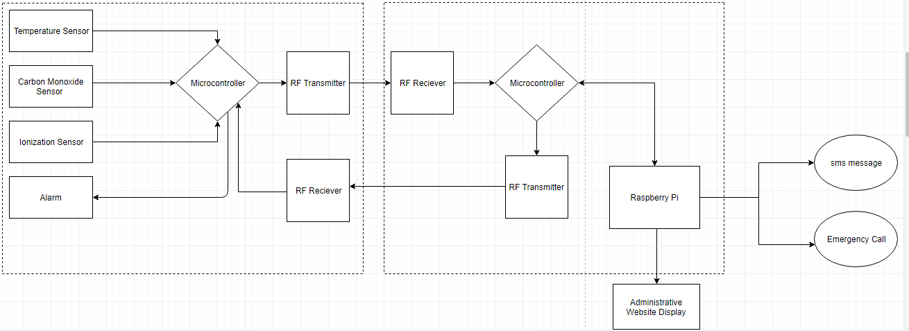

Figure 4: Flow Chart

## System Functions

1. When either of the sensor thresholds is tripped it will transmit a message signal that will be processed by the Arduino.
2. The Arduino will process this signal and transmit it via the RF transmitter module and also activate a Piezo buzzer as an instant alert notification.
3. This will signal will be received by the RF receiver that will pass this information through a second Arduino and then pass the signal through a logic level converter.
4. The signal will then be passed to the raspberry pi which will interoperate the data signal, determine its node ID, and determine the exact nature and origin of the problem within the building.
5. This will then instantiate the PLIVO program and transmit an autonomous phone call to emergency services notifying them of the nature and origin of the problem within the structure. While this process is occurring the raspberry pi will send out a SMS warning message to all registered occupant phone numbers within the database.
6. The potential threat will be updated to the administrative web page, its location within the building will be highlighted, and possible escape routes will be calculated and displayed.
7. **Implementation Plan**

## Tasks

* Task 1. Sensor Design
  + Subtask 1. Design program for Temperature Sensor.
  + Subtask 2. Design program for Ionization Sensor.
  + Subtask 3. Design program for Carbon Monoxide Sensor.
  + Subtask 4. Configure microcontroller with all three sensors.
  + Subtask 5. Design PCB for transmitter.
  + Subtask 6. Design PCB for receiver.
  + Subtask 7. Design and Configure Motion detector sensor.
* Task 2. Wireless Sensor Network Design
  + Subtask 1. Configure microcontroller and RF transmitter interface.
  + Subtask 2. Program microcontroller and RF transmitter.
  + Subtask 3. Configure microcontroller and RF receiver interface.
  + Subtask 4. Program microcontroller and RF receiver interface.
  + Subtask 5. Design program that will optimize bandwidth to hold all sensor data.
  + Subtask 6. Configure microcontroller and raspberry pi.
  + Subtask 7. Configure raspberry pi to retrieve, display, and store node data.
  + Subtask 8. Design a program that will interpret node data and transfer it to the webpage.
  + Subtask 9. Configure raspberry pi and website for node data processing and storage.
  + Subtask 10. Design voice alarm notification platform for building occupants.
* Task 3. Website Design
  + Subtask 1. Design background and layout of website.
  + Subtask 2. Design login for administrator and user access.
  + Subtask 3. Program a grid that will establish compartments for each room in building.
  + Subtask 4. Design a program that will interface the raspberry pi and website.
  + Subtask 5. Design a program that will pair node ID with corresponding room on the grid plan.
  + Subtask 6. Program grid to highlight room where potential threat arises.
* Task 4. Configure raspberry pi and website.
  + Subtask 1. Design program that will transmit and display WSN data on webpage.
  + Subtask 2. Design program that will display warning messages from pi on webpage.
  + Subtask 3. Configure node ID data from raspberry pi with website.
  + Subtask 4. Program alarm system shut off for administrative use.
  + Subtask 5. Program administrative link for admin to upload floor plan to website.
  + Subtask 6. Program website to receive and notify administrator when motion detector is tripped.
* Task 5. Design Automated Emergency Phone Call
  + Subtask 1. Setup PLIVO account and install corresponding software on raspberry pi.
  + Subtask 2. Configure PLIVO with wireless sensor network.
  + Subtask 2. Design a virtual autonomous alert message for each specific node ID.
  + Subtask 3. Design program that will allocate voice node ID numbers to specific automated dispatch message.
  + Subtask 4. Program each specific node ID for a specific SMS message transmission.
  + Subtask 4. Configure raspberry pi for SMS data transmission.
* Task 6. Design SMS Warning Message Database
  + Subtask 1. Design database for building occupant phone number storage.
  + Subtask 2. Design program to send link to the webpage.
  + Subtask 3. Configure SMS warning message with building occupant phone number database.
* Task 7. Design 3-D printed housings for transmitter and receiver modules
  + Subtask 1. Design cad model for transmitter housing.
  + Subtask 2. Design cad model for receiver housing.
  + Subtask 3. Print transmitter and receiver housings.
* Task 8. Complete System Assembly and Testing
  + Subtask 1. Assemble entire system.
  + Subtask 2. Test full platform with nodes placed in their desired positions.
  + Subtask 3. Test all warning message software and assure they work properly.

## Team Organization

### Responsibility of Team Member 1 (David Goslee).

Task 1, Subtask 1.1, 1.2, 1.3, 1.5

Task 2, Subtask 2.8, 2.9, 2.10

Task 4, Subtask 4.1, 4.2, 4.3, 4.4

Task 5, Subtask 5.3, 5.4

Task 8, Subtask 8.1, 8.2, 8.3

### Responsibility of Team Member 2 (Israel Akinsoyinu).

Task 1, Subtask 1.6, 1.7

Task 2, Subtask 2.1, 2.2, 2.3, 2.4, 2.6, 2.7

Task 5, Subtask 5.1, 5.2

Task 7, Subtask 7.1, 7.2, 7.3

Task 7, Subtask 8.1, 8.2, 8.3

### Responsibility of Team Member 3 (Dedrick McCoy).

Task 3, Subtask 3.1, 3.2, 3.3, 3.4, 3.5

Task 4, Subtask 4.1, 4.2, 4.3, 4.4, 4.5, 4.6

Task 6, Subtask 8.1, 8.2, 8.3

## Timeline/Milestones/Delivery Plan

1. **Project Timeline and Delivery Plan**

|  |  |  |  |
| --- | --- | --- | --- |
| **Week Number** | ***David*** | ***Dedrick*** | ***Israel*** |
| **Week 1** | *Subtask 1.1-1.3:*  Design Program for DHT22, MQ-2, and MQ-7 | *Subtask 3.1-3.2:*  Design back ground and website logins for user and administrator. | *Subtask 2.1-2.4:*  Configure and Program RF transmitter and receiver with Arduino. |
| **Week 2** |
| **Week 3** | *Subtask 2.5:*  Design program to hold and transmit all sensor data. | *Subtask 2.6-2.7:*  Configure Arduino and Raspberry pi to receive and display node data. |
| **Week 4** | *Subtask 3.3:*  Program a grid that will establish compartments for each room. |
| **Week 5** | *Subtask 1.5:*  Design PCB for transmitter. | *Subtask 1.6:*  Design PCB for receiver. |
| **Week 6** | *Subtask 3.4:*  Design a program that will interface raspberry pi and website. |
| **Week 7** |
| **Week 8** | *Subtask 3.5-3.6:*  Design a program that will pair node ID’s with rooms and program gird to highlight potential threat. |
| **Week 9** | *Subtask 2.8-2.9:*  Design program that will interoperate node data and transfer it to webpage and configure raspberry pi and webpage. | *Subtask 5.1-5.2:*  Setup and Configure PLIVO with raspberry pi |
| **Week 10** |
| **Week 11** | *Subtask 5.3:*  Design program that will allocate node ID’s with specific automated calls. |
| **Week 12** | *Subtask 6.1:*  Design local database for occupant phone number storage. | *Subtask 4.1-4.2:*  Design program that will transmit and display node data on webpage and a program to display warning messages. |
| **Week 13** | *Subtask 6.2-6.3:*  Design a program to send building occupants the threat location within the building structure and a link to the webpage (cloud). |
| **Week 14** |
| **Week 15** | *Subtask 5.4-5.5:*  Configure Pi for SMS transmission and Program each node to specific SMS corresponding node location within the building (local). | *Subtask 4.3-4.5:*  Program administrative shut off for alarm system and link for floor plan upload. |
| **Week 16** |
| **Week 17** | *Subtask 2.10:*  Design Voice Alarm notification system for each node. | *Subtask 7.1-7.3:*  Design CAD models for transmitter and receiver housings. |
| **Week 18** | *Subtask 4.6:*  Program website to receive and notify administrator when motion detector is tripped. |
| **Week 19** | *Subtask 1.7:*  Configure and program motion detector for alarm detection nodes. |
| **Week 20** |
| **Week 21** | *Subtask 8.1-8.3:* Full System assembly and testing. | *Subtask 8.1-8.3:* Full System assembly and testing. | *Subtask 8.1-8.3:* Full System assembly and testing. |
| **Week 22** |

1. **Implementation**

## Implementation of Task 1 Sensor Design.

### Implementation of Subtask 1.1

The implementation of subtask 1.1 is the design of program and circuit for a temperature sensor. The sensor that was chosen for this part of the project is the Adafruit DHT22 Temperature and Humidity Sensor. To implement this task first the Adafruit DHT source file must be downloaded and extracted into your project folder. It is imperative that this file be extracted into the proper folder so that the libraries can be utilized for the DHT22 program code. If this is not done properly all definition statements written for the DHT22 sensor will cause the Arduino IDE compiler to throw an error when attempting to upload the code to the board. If one is using a four pin DHT22 as exemplified in the figure below the far right pin is the ground pin, the far left pin is the 5V input pin, the pin directly to the right of the 5V pin is the data pin, and the last pin is a reference pin. If one is using a DHT22 with three pins. The far right pin will be the ground pin, the far right pin will be 5V input pin, and the middle pin will be the data pin. The DHT22 will be connected to digital pin seven on the Arduino board as exemplified below.

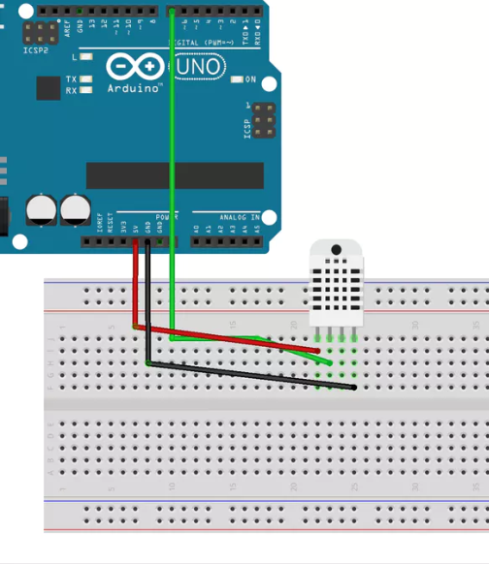

Figure 5: Adafruit DHT22 Circuit Diagram.

* + 1. ***Implementation of Subtask 1.2***

The implementation of subtask 1.2 is the design of a program and circuit for the flying fish MQ-7 carbon monoxide detector. This sensor was chosen for the implementation of this part of the project because of its precise calibration for the detection of harmful and poisonous gases. The MQ-7 fluctuates between a high and low voltage process that allows the device to clean its base plate before each reading thus affording a more accurate value for its user. No libraries are needed for this particular sensor only the program and circuit have to be built for complete operation. There are two ways to achieve this task the first is to build a complex circuit using capacitors, a NPN transistor, and multiple resistors to fluctuate the input voltage from 5V to 1.4V thus achieving the proper cleaning process for an accurate reading. The second is to hard code the voltage drop within the Arduino code itself. This will allow the microcontroller to fluctuate its own voltage over a specified range of time. The cleaning process needs to occur for a sixty second period and the reading must be taken directly after this process takes place to ensure that the device obtains an accurate reading. This sensor must be read using the analog pins of the Arduino because it does not contain a digital chip on its own board. The A0 pin on the Arduino must be utilized as a constant reference pin so that the device can differentiate between its high and low voltage fluctuations to achieve an accurate data reading.

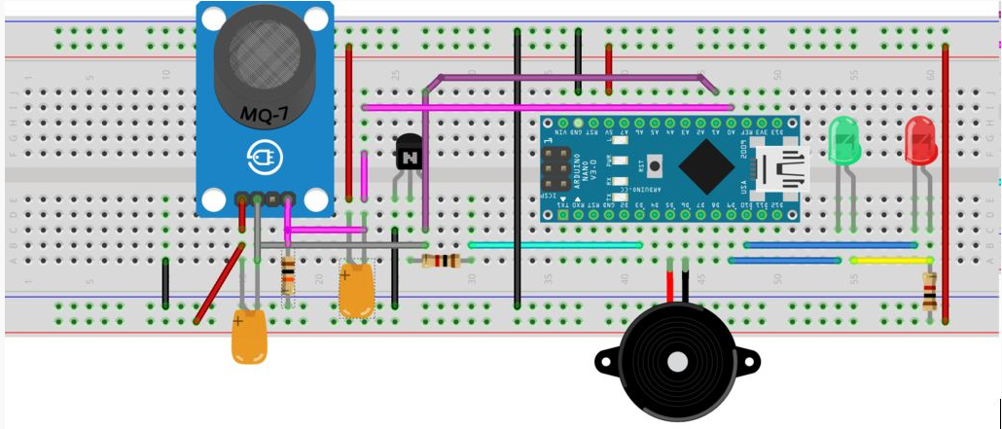

Figure 6(a): First Flying Fish MQ-7 circuit diagram.

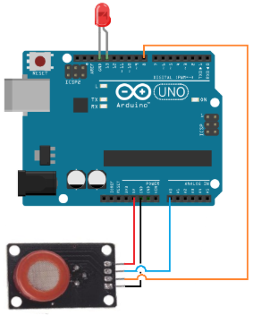

Figure 6(b): Second Flying Fish MQ-7 circuit diagram.

* + 1. ***Implementation of Subtask 1.3***

The implementation of subtask 1.3 is the design of a program and circuit for the Flying Fish MQ-2 ionization sensor. This sensor was chosen because of its high accuracy for detecting air born particulate which is a major benefit for detecting smoldering fires. For this sensor no libraries are needed to ensure that the sensor functions properly only the code and a proper circuit need be implemented. The MQ-2 input must be read using the analog pins because there is no chip on its board to convert the reading into a digital signal. This sensor does not require any special calibration technique to achieve a proper measurement. To ensure that the code for this sensor is executing properly it is hardwired to a circuit with two LED’s and a Piezo buzzer. If the circuit is in normal operation the MQ-2 will begin reading and transmitting data and if no smoke is detected the Piezo buzzer will be silent and the green LED will stay lit. If the MQ-2 sensor threshold is tripped then the red LED will light and the Piezo buzzer will initiate a high frequency ring until the sensor gains a reading that is below the set threshold value. In the circuit exemplified below the MQ-2 has four pins. The far left pin is the 5V input pin, the next pin directly to the right is the ground pin, the next pin directly to the right is the digital data pin, and the last pin is the analog data pin. For this particular project as mention in the above text the analog pin is being utilized for the MQ-2 and it is connected to Analog pin 5 on the Arduino board. The 5V input of the Piezo buzzer is connected to the Digital 10 pin, and the ground pin is connected to ground via a 110 ohm resistor. Likewise, the green LED is connected to Digital 11 pin and the Red LED is connected to the digital 12 pin of the Arduino board. Again both LED’s are connected to ground via 110 ohm resistors to stabilize their input signals.

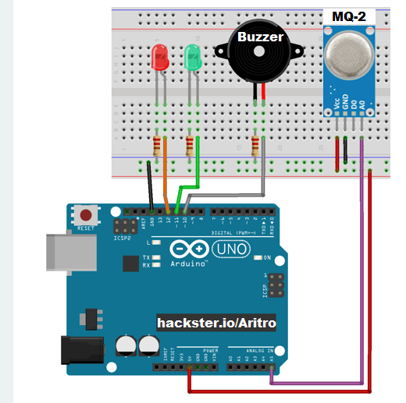

Figure 7: Flying Fish MQ-2 Circuit Diagram.

* + 1. ***Implementation of Subtask 1.4***

The implementation of subtask 1.4 is the complete integration of all three sensors with the alarm circuit. The most critical component of this task is the proper integration of all code for each of these sensors into one contiguous block of code that functions for them all. For this the Adafruit libraries must be present in the project directory to ensure the definition statements for the DHT22 temperature and humidity sensor do not cause a compilation error. Careful consideration is needed for the integration of this circuit and it is imperative that all wires are connected to their proper input pins. As exemplified in the figure below the Piezo buzzer is connected to the digital 6 pin on the Arduino, and is grounded across a 110 ohm resistor. The MQ-2 is directly beside the DHT22 temperature and humidity sensor and is connected to the analog pin A2 on the Arduino board. The MQ-7 carbon monoxide sensor is connected to analog pin A5 on the Arduino board. Finally the DHT22 remains connected to the digital input pin 7 on the Arduino board.

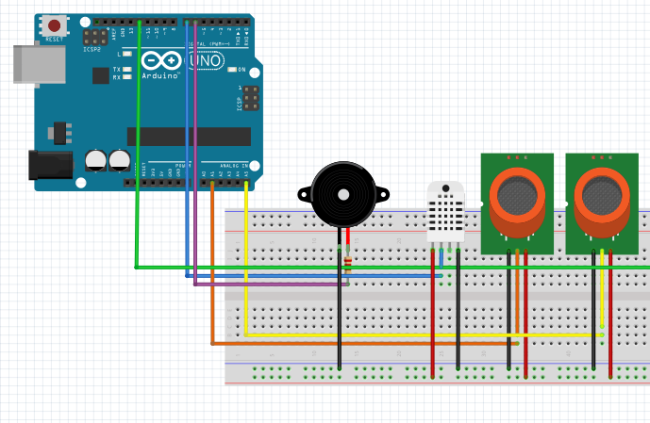

Figure 8: Full alarm circuit layout with all sensors.

* + 1. ***Implementation of Subtask 1.5***

The implementation of subtask 1.5 is the design of a printed circuit board for the transmitter for this project. This board will contain an Arduino Nano, MQ-7, MQ-2, DHT22, piezo buzzer, two LED’s, and a RF transmitter module. There are a multitude of free programs that one can use when designing a PCB. The top three choices are Fritzing, KiCad, and Eagle. For this particular project KiCad was chosen for as it is a more efficient platform for the implementation of custom built parts. The first thing to do is to find the official KiCad sit and initiate the download for your particular device (either MAC OS or Windows). Once this has been completed open the program and create a new project file and name it transmitter. Then click on the schematic view and start by adding the simplest elements that already exist within KiCad’s built in libraries. Those components would be the 110 ohm resistor, the piezo buzzer, Arduino Nano, and the LED’s. Once these have been inserted into the schematic it is time to create the custom sensors needed for this particular PCB. To achieve this click on the new symbol link in the schematic view. Once this is done one can create as many new symbols as they want. Use the data sheet and pin layout to create each corresponding sensor and then save them all in a new folder titled my sensors. After all custom sensors are created simply insert them into the schematic and wire the circuit accordingly. Now for the second step it is time to assign footprints to each of the elements within the transmitter schematic. To do this click the foot notes button in the schematic view and a dialog box will show up. Match each device to its corresponding foot note and then save the schematic. Now it is finally time to import the wiring schematic into the PCB view within KiCad. Do not worry that all the elements are jumbled and out of order simply hit ctrl ‘M’ and move the pieces into their proper orientation or the orientation of choice. Finally inspect each layer of the PCB and ensure all connections are where they are supposed to be and save the PCB to the transmitter project file.

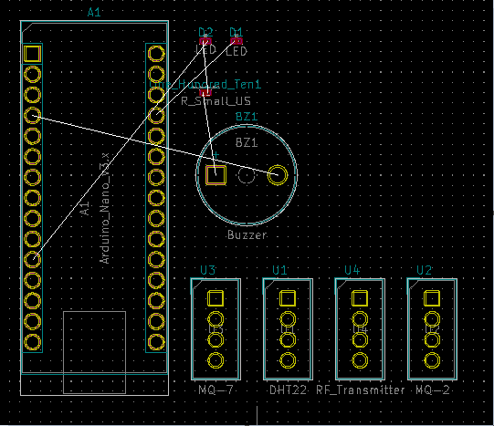

Figure --: PBC design for transmitter

* + 1. ***The Implementation of Subtask 1.6***

The implementation of subtask 1.6 is the design of a printed circuit board for the receiver module of this project. To implement this task create a new project folder in KiCad and save the project name as Receiver. First open the schematic view, place the cursor over the place button, and select add a symbol from the drop down menu. After the window opens type in Arduino Nano in the search bar and press enter. Select the Arduino Nano and insert it in the schematic window. This same process will be followed for inserting the LED, RF receiver, and the Antenna modules. Once all symbols have been inserted into the schematic place them in a logical manner and begin the wiring process. To do this select the place wire button on the right hand too bar and connect the modules to their respective outputs and inputs on the Arduino Nano. Once this step is completed it is time to add footprints for each of the schematic pieces so they can be transferred to the PCB view. To do this select the assign PCB footnotes button on the tool bar and wait for the dialog box to appear. Then link each corresponding part to its proper footnote and it is time to start the implementation. Select the generate netlist box on the upper tool bar and this will push all assigned footnotes to the PCB view. Then select the PCB view and properly orient the newly inserted parts into view. The second to last step is to select the routing tool from the right hand tool bar and route each of the wires to their respective ports. Finally once this is accomplished select then add a graphic tool on the right hand tool bar and draw a proper boarder around the newly created PCB.

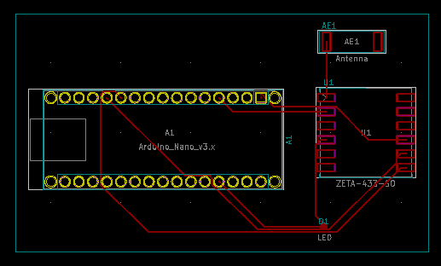

Figure --: PCB design for receiver.

## Implementation of Task 2 Wireless Sensor Network Design.

* + 1. ***Implementation of Subtask 2.1***

The implementation of subtask 2.1 is the configuration of the circuit for the Arduino and RF transmitter. This is a relatively simple process as there are only two components that are needed for this portion of the project. Those two components are a 433 MHz transmitter and an Arduino UNO. As exemplified in Figure 6 below the 433 MHz transmitter has three pins. The far left pin on the transmitter is the data input pin, the middle pin is the ground pin, and the pin on the far right of the transmitter is the 5V input pin. The receiver input data pin is connected to the digital output pin of the Arduino board and the 5V input and ground pins are connected to their corresponding pins on the Arduino.

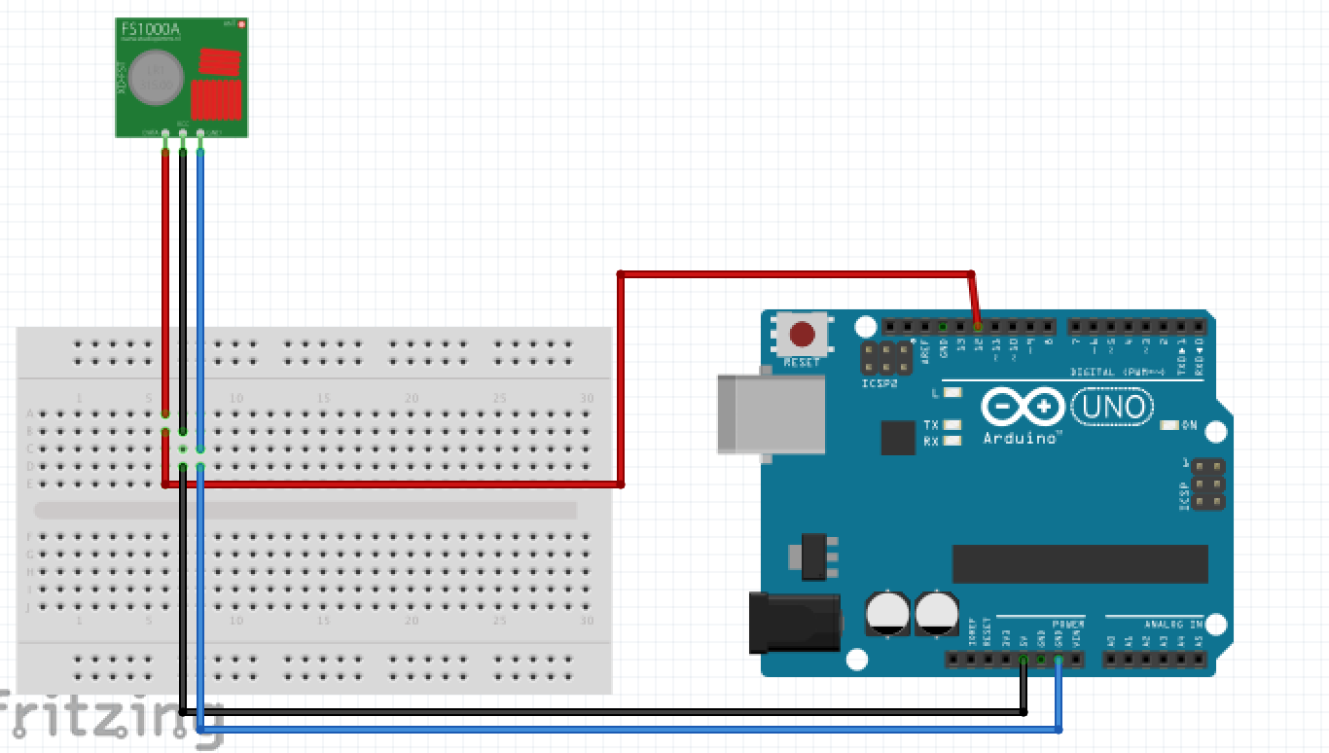

Figure 9: Circuit diagram for Geekcreit RF transmitter.

* + 1. ***Implementation of Subtask 2.2***

The implementation of subtask 2.2 is the design of a program for the Arduino and RF transmitter. For this part of the project the Virtual Wire and Radio Head zip file libraries need to be downloaded and extracted into the project folder. These two libraries will be crucial for instantiating the transmission and acquisition pins on the Arduino board. Once these libraries have been successfully extracted into the project folder one can start writing the actual code for the transmitter. Be sure to include the <VirtualWire.h> declaration at the beginning of the program and set your reference pin to digital pin 13. Once this is done set the TX pin on the Arduino for pin 12 and the bandpass rate for data transmission to two thousand bps. Once this is done simply build the code that is needed for proper data transmission and upload it to the Arduino board.

* + 1. ***Implementation of Subtask 2.3***

The implementation of subtask 2.3 is the configuration of the 433 MHz RF receiver and Arduino circuit. This task is again relatively short as there are only two components needed for the succession of this task. Those two components again being the Arduino UNO and the 433 MHz RF receiver. As exemplified by the circuit in Figure 7 below the 433 MHz receiver has four pins on its board. The far left pin is the 5V power input pin, the two pins to the right of the power pin are the digital and analog ground pins, and the final pin on the far right is the data input pin. The data pin is connected to digital pin 11 on the Arduino board, the ground pin is connected to digital ground, and the power pin is connected to the 5V output pin respectively.

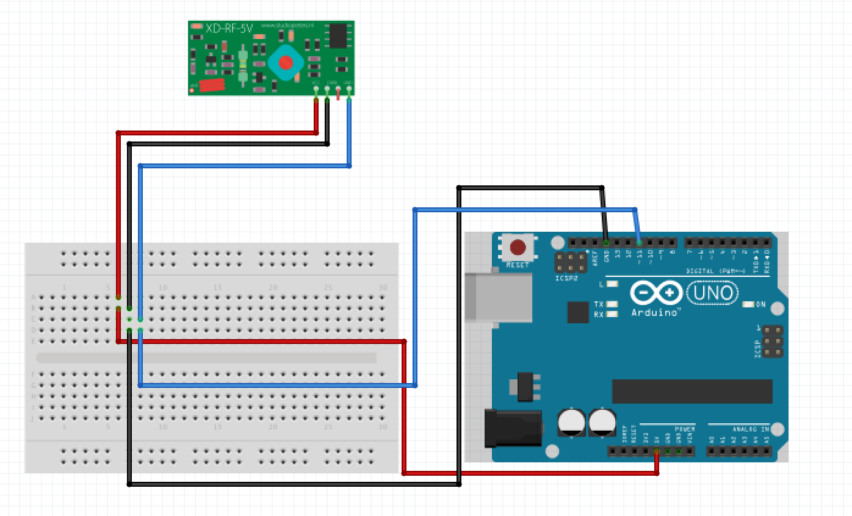

Figure 10: Circuit diagram for Geekcreit RF receiver.

* + 1. ***Implementation of Subtask 2.4:***

The implementation of subtask 2.4 is the design of a program for the 433 MHz RF receiver and Arduino. Once again for this part of the project the Virtual Wire and Radio Head zip file libraries need to be downloaded and extracted into the project folder. These two libraries will be crucial for instantiating the transmission and receiving pins on the Arduino board. For this program again the <VirtualWire.h> library must be included and the reference pin will remain the constant as pin 13. The data input pin from the transmitter to the receiver will be set at 11 and the bps acquisition rate for the data should be set to begin at 9600 bps. Once these constants have been set the program can be built. Set the RX pin to data pin 11 in the program code and be sure to start the RX program. Once this is done move on to the void loop of the program code and insert the buffer length and an if-else statement to see if the data has been transmitted and acquired. Finally once this is done upload the program code to the Arduino board and test the complete system to see if data is being transmitted. To do this go to the tools drop down menu on in Arduino IDE and select the serial monitor tab. The communication port should open and you should see the message displayed in Figure 8.

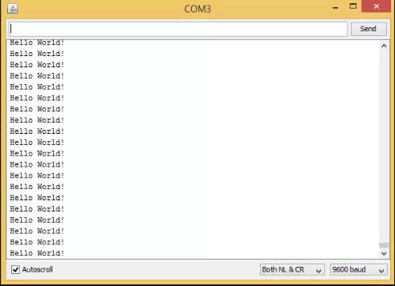

Figure 11: Geekcreit 433 MHz RF transmitter output.

* + 1. ***Implementation of Subtask 2.5***

The implementation of subtask 2.5 is the configuration of all sensors with the RF receiver and transmitter. To accomplish this task two separate breadboards and Arduinos will be utilized. The bread board with all of the interfaced sensors will be utilized for the transmitter. The only thing that needs to be added to the circuit is the RF transmitter itself. It will need to be grounded and will require a 5V power input from the Arduino board. The data pin will be connected to the digital input pin 11 on the Arduino board. The circuit is exemplified by Figure 9(a) and all components and connections can clearly be visualized. For the second board nothing need be changed from its original circuit layout in subtask 4.2.4. The circuit diagram for the receiver is exemplified by Figure 9(b) and all connections are cleared represented.

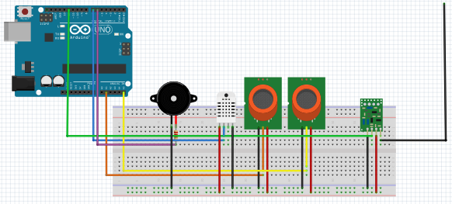

Figure 12(a): Complete implementation of RF transmitter circuit.

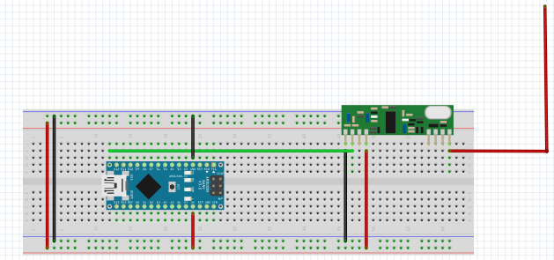

Figure 12(b): Complete implementation of RF receiver circuit.

* + 1. ***Implementation of Subtask 2.6***

The implementation of subtask 2.6 is the configuration of the raspberry pi and Arduino. There are two ways of implementing this particular part of the project. If one choses to use an IoT platform then a logic level converter is needed for the communication of the raspberry pi and Arduino. The logic level converter steps the 5V output voltage of the Arduino down to 3.3V so the raspberry pi can process the data being transferred over the TX and RX pins of each device. When wiring the logic level converter the TX pin from the Arduino will go to the TX input on the converter and the RX pin will go to the RX input respectively. However, for the raspberry pi the RX output from the converter will go to the TX pin of the pi and the TX output from the converter will go to the RX pin of the pi. The 5V output voltage from the Arduino will be wired to the input voltage V1 on the converter and the 3.3V output voltage from the pi will be wired into V2 respectively. Each ground will be wired to their corresponding grounds on either side of the logic level converter. For the second option no logic level converter is needed and the Arduino is connected directly to one of the four USB ports located on the back of the pi itself. No other wiring is needed for that portion. However, if one chooses this option there is back end work that needs to be completed to ensure that the pi and microcontroller are configured properly. First one needs to SSH into the pi and make sure the device is up to date, and I2C and serial port commination are enabled. Once this is done download the Arduino library from the Raspberian website and install it on the device. Once these steps have been completed plug in the Arduino to the raspberry pi and type the following commands /dev/ttyAM0* a grid of data will appear and find the ttyAM (‘your ID number’) corresponding to your particular Arduino (each Arduino ID is unique). Once this has been found the pi and Arduino will have been successfully configured.

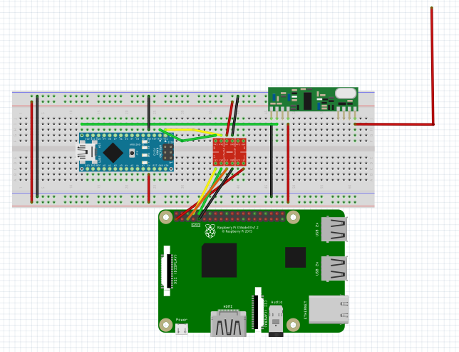

Figure -- : Configuration of Raspberry pi and Arduino with logic level converter.

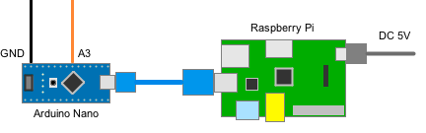

Figure --: Configuration of Raspberry pi and Arduino using direct USB connection.

* + 1. ***Implementation of Subtask 2.7***

The implantation of Subtask 2.7 is to configure raspberry pi to retrieve, display, and store node data. For this portion of the project the Arduino and Raspberry Pi must be configured properly in subtask 2.6 or data retrieval will be impossible. To make this possible there are a multitude of different approaches to take. The approach that this project takes is by directly reading in the transmitted data from the Arduino to the Raspberry Pi via the USB connection and then printing that data to the Raspberry Pi’s serial monitor. To do this one will need to create a python file called transmitter.py inside of the user/bin/home directory of the raspberry pi. Once this has been completed one can start designing the program that will interoperate and store the data. To accomplish this first use the import command to import serial which will instantiate the USB connection between the Raspberry Pi and the Arduino. After this is accomplished use the serial.read(‘your device info’) command to read in the data. Then use the command to output that data to a text file so it can be stored for further operations later in the project. The output should look similar to the figure below.

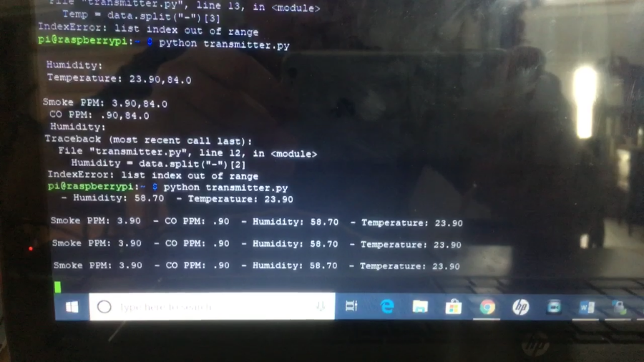

Figure --: Terminal output from raspberry pi.

## Implementation of Task 3 Website Design

***4.3.1 Implementation of subtask 3.1***

Subtask 3.1 is the design of the background and layout of the website. The purpose of the website is so the owner or manager has access to the layout of the building, readings from the sensors and to have a place to store employee information. Along with the layout, the building diagram will have a grid programmed over it. This grid will allow whatever room, hallway or other area to flash red when the detector for that corresponding area is going off. The employee information stores the name and phone number of the employees. Once the numbers are stored, the raspberry pi phone will be able to access these numbers and alert the employees via SMS messaging.

***4.3.2 Implementation of subtask 3.2***

Subtask 3.2 is implementing a registration and login system so that the website can be more secure. When the user registers, they need to input an email, username, answers to a series of security questions and password, which needs to be confirmed. Once the registration form is submitted, the user will then be directed to the homepage of the website and the information will be stored so that the user can log in later using that information. A “forgot password” function is also incorporated. Once the user clicks on “reset password”, they will be directed to a page in which they must correctly answer the security questions before being able to change the password.

1. **Conclusion (Discussion and Future Plans)**

**Acknowledgment**

**Appendix**

1. **Component Specs**
2. ***Specs of Arduino UNO***
   1. Microcontroller: ATmega328
   2. Operating Voltage: 5V
   3. Input Voltage (recommended): 7-12V
   4. Input Voltage (limits): 6-20V
   5. Digital I/O Pins: 14 (of which 6 provide PWM output)
   6. Analog Input Pins: 6
   7. DC Current per I/O Pin: 40 mA
   8. DC Current for 3.3V Pin: 50 mA
   9. Flash Memory: 32 KB of which 0.5 KB used by bootloader
   10. SRAM: 2 KB (ATmega328)
   11. EEPROM: 1 KB (ATmega328)
   12. Clock Speed: 16 MHz
3. ***Specs of Arduino NANO***
   1. Microcontroller ATmega328
   2. Operating Voltage (logic level): 5 V
   3. Input Voltage (Recommended): 7-12 V
   4. Input Voltage (limits): 6-20 V
   5. Digital I/O Pins : 14 (of which 6 provide PWM Output)
   6. Analog Input Pins: 8
   7. DC Current per I/O Pin: 40 mA
   8. Flash Memory 32 KB (ATmega328) of which 2 KB used by bootloader
   9. SRAM: 2 KB (ATmega328)
   10. EEPROM: 1 KB (ATmega328)
   11. Clock Speed: 16 MHz
   12. Measurements: 0.73" x 1.70"
4. ***Specs of Raspberry Pi 3***
   1. SoC: Broadcom BCM2837.
   2. CPU: 4× ARM Cortex-A53, 1.2GHz.
   3. GPU: Broadcom VideoCore IV.
   4. RAM: 1GB LPDDR2 (900 MHz)
   5. Networking: 10/100 Ethernet, 2.4GHz 802.11n wireless.
   6. Bluetooth: Bluetooth 4.1 Classic, Bluetooth Low Energy.
   7. Storage: microSD.
   8. GPIO: 40-pin header, populated.
5. ***Specs of MQ-2 Smoke Sensor***
   1. Operating Voltage is +5V
   2. Can be used to Measure or detect LPG, Alcohol, Propane, Hydrogen, CO and even methane
   3. Analog output voltage: 0V to 5V
   4. Digital Output Voltage: 0V or 5V (TTL Logic)
   5. Preheat duration 20 seconds
   6. Can be used as a Digital or analog sensor
   7. The Sensitivity of Digital pin can be varied using the potentiometer
6. ***Specs of MQ-7 Carbon Monoxide Sensor***
   1. Sensitive for carbon monoxide
   2. Output voltage boosts along with the concentration of the measured gases increases
   3. Fast response and recovery
   4. Adjustable sensitivity
   5. Signal output indicator
   6. Power: 2.5V ~ 5.0V
   7. Dimension: 40.0mm * 21.0mm
   8. Mounting holes size: 2.0mm
   9. VCC ↔ 2.5V ~ 5.0V
   10. GND ↔ power supply ground
   11. AOUT ↔ MCU.IO (analog output)
   12. DOUT ↔ MCU.IO (digital output)
7. ***Specs of DHT22 Temperature and Humidity Sensor***
   1. Low cost
   2. 3 to 5V power and I/O
   3. 2.5mA max current use during conversion (while requesting data)
   4. Good for 0-100% humidity readings with 2-5% accuracy
   5. Good for -40 to 80°C temperature readings ±0.5°C accuracy
   6. No more than 0.5 Hz sampling rate (once every 2 seconds)
   7. Body size 27mm x 59mm x 13.5mm (1.05" x 2.32" x 0.53")
   8. 4 pins, 0.1" spacing
   9. Weight (just the DHT22): 2.4g
8. ***Specs of 433 MHz RF Receiver***
   1. Wireless (RF) Simplex Transmitter and Receiver
   2. Receiver Operating Voltage: 3V to 12V
   3. Receiver Operating current: 5.5mA
   4. Operating frequency: 433 MHz
   5. Transmission Distance: 3 meters (without antenna) to 100 meters (maximum)
   6. Modulating Technique: ASK (Amplitude shift keying)
   7. Data Transmission speed: 10Kbps
   8. Circuit type: Saw resonator
   9. Low cost and small package
9. ***Specs of 433 MHz RF transmitter***
   1. Wireless (RF) Simplex Transmitter and Receiver
   2. Transmitter Operating Voltage: +5V only
   3. Transmitter Operating current: 9mA to 40mA
   4. Operating frequency: 433 MHz
   5. Transmission Distance: 3 meters (without antenna) to 100 meters (maximum)
   6. Modulating Technique: ASK (Amplitude shift keying)
   7. Data Transmission speed: 10Kbps
   8. Circuit type: Saw resonator
   9. Low cost and small package
10. ***Specs of 4-Channel Logic Level Converter***
    1. Logic level shifter Bi-Directional with 4 channels between high logic and low logic
    2. Small module with 1.3cm X 1.5cm
    3. With 2 rows of 6 pin
11. ***Specs of Piezo Buzzer***
    1. Wide operating voltage: 3~250 V
    2. Lower current consumption: less than 30 mA higher rated frequency
    3. Larger footprint
    4. Higher sound pressure level
12. **Source Code.**
13. ***Source Code of DHT22 Temperature and Humidity Sensor***

// DHT Temperature & Humidity Sensor

// Unified Sensor Library Example

// Written by Tony DiCola for Adafruit Industries

// Released under an MIT license.

// REQUIRES the following Arduino libraries:

// - DHT Sensor Library: https://github.com/adafruit/DHT-sensor-library

// - Adafruit Unified Sensor Lib: https://github.com/adafruit/Adafruit_Sensor

#include <Adafruit_Sensor.h>

#include <DHT.h>

#include <DHT_U.h>

#define DHTPIN 2 // Digital pin connected to the DHT sensor

// Feather HUZZAH ESP8266 note: use pins 3, 4, 5, 12, 13 or 14 --

// Pin 15 can work but DHT must be disconnected during program upload.

// Uncomment the type of sensor in use:

//#define DHTTYPE DHT11 // DHT 11

#define DHTTYPE DHT22 // DHT 22 (AM2302)

//#define DHTTYPE DHT21 // DHT 21 (AM2301)

// See guide for details on sensor wiring and usage:

// https://learn.adafruit.com/dht/overview

DHT_Unified dht(DHTPIN, DHTTYPE);

uint32_t delayMS;

void setup() {

Serial.begin(9600);

// Initialize device.

dht.begin();

Serial.println(F("DHTxx Unified Sensor Example"));

// Print temperature sensor details.

sensor_t sensor;

dht.temperature().getSensor(&sensor);

Serial.println(F("------------------------------------"));

Serial.println(F("Temperature Sensor"));

Serial.print (F("Sensor Type: ")); Serial.println(sensor.name);

Serial.print (F("Driver Ver: ")); Serial.println(sensor.version);

Serial.print (F("Unique ID: ")); Serial.println(sensor.sensor_id);

Serial.print (F("Max Value: ")); Serial.print(sensor.max_value); Serial.println(F("°C"));

Serial.print (F("Min Value: ")); Serial.print(sensor.min_value); Serial.println(F("°C"));

Serial.print (F("Resolution: ")); Serial.print(sensor.resolution); Serial.println(F("°C"));

Serial.println(F("------------------------------------"));

// Print humidity sensor details.

dht.humidity().getSensor(&sensor);

Serial.println(F("Humidity Sensor"));

Serial.print (F("Sensor Type: ")); Serial.println(sensor.name);

Serial.print (F("Driver Ver: ")); Serial.println(sensor.version);

Serial.print (F("Unique ID: ")); Serial.println(sensor.sensor_id);

Serial.print (F("Max Value: ")); Serial.print(sensor.max_value); Serial.println(F("%"));

Serial.print (F("Min Value: ")); Serial.print(sensor.min_value); Serial.println(F("%"));

Serial.print (F("Resolution: ")); Serial.print(sensor.resolution); Serial.println(F("%"));

Serial.println(F("------------------------------------"));

// Set delay between sensor readings based on sensor details.

delayMS = sensor.min_delay / 1000;

}

void loop() {

// Delay between measurements.

delay(delayMS);

// Get temperature event and print its value.

sensors_event_t event;

dht.temperature().getEvent(&event);

if (isnan(event.temperature)) {

Serial.println(F("Error reading temperature!"));

}

else {

Serial.print(F("Temperature: "));

Serial.print(event.temperature);

Serial.println(F("°C"));

}

// Get humidity event and print its value.

dht.humidity().getEvent(&event);

if (isnan(event.relative_humidity)) {

Serial.println(F("Error reading humidity!"));

}

else {

Serial.print(F("Humidity: "));

Serial.print(event.relative_humidity);

Serial.println(F("%"));

}

}

1. ***Source Code of MQ-2 Smoke Sensor***

int redLed = 12; // red LED pin

int greenLed = 11; // green LED pin

int buzzer = 10; // Piezo Buzzer pin

int smokeA0 = A5; // MQ-2 analog output pin

// Your threshold value

int sensorThres = 18;

void setup() {

pinMode(redLed, OUTPUT);

pinMode(greenLed, OUTPUT);

pinMode(buzzer, OUTPUT);

pinMode(smokeA0, INPUT);

Serial.begin(9600);

}

void loop() {

int analogSensor = analogRead(smokeA0);

Serial.print("Pin A0: ");

Serial.println(analogSensor);

// Checks if it has reached the threshold value

if (analogSensor > sensorThres)

{

digitalWrite(redLed, HIGH); // Will light red LED if threshold value is reached.

digitalWrite(greenLed, LOW); // Will not light green LED if threshold value is reached.

tone(buzzer, 1000, 200); // Will activate buzzer if threshold value is reached.

}

else

{

digitalWrite(redLed, LOW); // Will not light red LED.

digitalWrite(greenLed, HIGH); // Will light green LED.

noTone(buzzer); // Buzzer will not be activated.

}

delay(100);

}

1. ***Source Code of MQ-7 Smoke Sensor***

#define analogMQ7 A0 // Signal

#define ledPin D7 // Device internal LED

int MQ7sensorValue = 0; // value read from the sensor

void setup()

{

Serial.begin(9600);

pinMode(analogMQ7, INPUT);

pinMode(ledPin, OUTPUT);

}

void loop() {

analogWrite(analogMQ7, HIGH); // HIGH = 255

// heat for 1 min

delay(60000);

// now reducing the heating power: turn the heater to approx 1,4V

analogWrite(analogMQ7, 71.4); // 255x1400/5000

// heat for 90 sec

delay(90000);

analogWrite(analogMQ7, HIGH);

delay(50); // Get an analog reading takes approx 100uSec

MQ7sensorValue = analogRead(analogMQ7);

Serial.print("MQ-7 PPM: ");

Serial.println(MQ7sensorValue);

if (MQ7sensorValue <= 200)

{

Serial.println("Air-Quality: CO perfect");

}

else if ((MQ7sensorValue > 200) || (MQ7sensorValue <= 800)) // || = or

{

Serial.println("Air-Quality: CO normal");

}

else if ((MQ7sensorValue > 800) || (MQ7sensorValue <= 1800))

{

Serial.println("Air-Quality: CO high");

}

else if (MQ7sensorValue > 1800)

{

digitalWrite(ledPin, HIGH); // optical information in case of emergency

Serial.println("Air-Quality: ALARM CO very high");

delay(3000);

digitalWrite(ledPin, LOW);

}

else

{

Serial.println("MQ-7 - cant read any value - check the sensor!");

}

}

1. ***Source Code of 433 MHz Transmitter***

#include <VirtualWire.h>

#include "DHT.h"

#define DHTPIN 4

#define DHTTYPE DHT22

const int led_pin = 13;

const int transmit_pin = 12;

struct package

{

float temperature ;

float humidity ;

};

typedef struct package Package;

Package data;

DHT dht(DHTPIN, DHTTYPE);

void setup()

{

// Initialise the IO and ISR

vw_set_tx_pin(transmit_pin);

vw_set_ptt_inverted(true); // Required for DR3100

vw_setup(500); // Bits per sec

pinMode(led_pin, OUTPUT);

}

void loop()

{

digitalWrite(led_pin, HIGH); // Flash a light to show transmitting

readSensor();

vw_send((uint8_t *)&data, sizeof(data));

vw_wait_tx(); // Wait until the whole message is gone

digitalWrite(led_pin, LOW);

delay(2000);

}

void readSensor()

{

dht.begin();

delay(1000);

data.humidity = dht.readHumidity();

data.temperature = dht.readTemperature();

}

1. ***Source Code of 433 MHz Receiver***

#include <VirtualWire.h>

#include <Adafruit_ST7735.h>

#include <Adafruit_GFX.h>

#define TFT_CS 10

#define TFT_RST 8

#define TFT_DC 9

Adafruit_ST7735 tft = Adafruit_ST7735(TFT_CS, TFT_DC, TFT_RST);

// Option 2: use any pins but a little slower!

#define TFT_SCLK 13 // set these to be whatever pins you like!

#define TFT_MOSI 11 // set these to be whatever pins you like!

const int receive_pin = 12;

char temperatureChar[10];

char humidityChar[10];

struct package

{

float temperature = 0.0;

float humidity = 0.0;

};

typedef struct package Package;

Package data;

void setup()

{

tft.initR(INITR_BLACKTAB);

tft.fillScreen(ST7735_BLACK);

printUI();

delay(1000);

// Initialise the IO and ISR

vw_set_rx_pin(receive_pin);

vw_setup(500); // Bits per sec

vw_rx_start(); // Start the receiver PLL running

}

void loop()

{

uint8_t buf[sizeof(data)];

uint8_t buflen = sizeof(data);

if (vw_have_message()) // Is there a packet for us?

{

vw_get_message(buf, &buflen);

memcpy(&data,&buf,buflen);

Serial.print("\nPackage:");

Serial.print(data.temperature);

//String temperatureString = String(data.temperature,1);

//temperatureString.toCharArray(temperatureChar,10);

//tft.fillRect(10,20,80,30,ST7735_BLACK);

//printText(temperatureChar, ST7735_WHITE,10,20,3);

//String humidityString = String(data.humidity,1);

//humidityString.toCharArray(humidityChar,10);

//tft.fillRect(10,95,80,100,ST7735_BLACK);

//printText(humidityChar, ST7735_WHITE,10,95,3);

Serial.print("\n");

Serial.println(data.humidity);

}

}

void printText(char *text, uint16_t color, int x, int y,int textSize)

{

tft.setCursor(x, y);

tft.setTextColor(color);

tft.setTextSize(textSize);

tft.setTextWrap(true);

tft.print(text);

}

void printUI()

{

printText("TEMPERATURE", ST7735_GREEN,30,5,1); // Temperature Static Text

printText("o", ST7735_WHITE,90,13,2);

printText("C", ST7735_WHITE,105,20,3);

printText("HUMIDITY", ST7735_BLUE,30,80,1); // Temperature Static Text

printText("%", ST7735_WHITE,90,95,3);

}

**REFERENCES**

[1] D. Vantrease, R. Schreiber, M. Monchiero, M. McLaren, N. P. Jouppi, M. Fiorentino*, et al.*, "Corona: System Implications of Emerging Nanophotonic Technology," in *Computer Architecture, 2008. ISCA '08. 35th International Symposium on*, 2008, pp. 153-164.

[2] X. Zhang and A. Louri, "A multilayer nanophotonic interconnection network for on-chip many-core communications," in *Design Automation Conference (DAC), 2010 47th ACM/IEEE*, 2010, pp. 156-161.

[3] C. Batten, A. Joshi, J. Orcutt, A. Khilo, B. Moss, C. Holzwarth*, et al.*, "Building manycore processor-to-DRAM networks with monolithic silicon photonics," in *High Performance Interconnects, 2008. HOTI '08. 16th IEEE Symposium on*, 2008, pp. 21-30.

[4] Y. Pan, P. Kumar, J. Kim, G. Memik, Y. Zhang, and A. Choudhary, "Firefly: illuminating future network-on-chip with nanophotonics," in *IEEE/ACM Intl. Symp. on Computer Architecture (ISCA)*, 2009, pp. 429-440.

[5] N. Kirman, M. Kirman, R. K. Dokania, J. F. Martinez, A. B. Apsel, M. A. Watkins*, et al.*, "Leveraging Optical Technology in Future Bus-based Chip Multiprocessors," in *Microarchitecture, 2006. MICRO-39. 39th Annual IEEE/ACM International Symposium on*, 2006, pp. 492-503.

[6] J. M. Cianchetti, C. J. Kerekes, and H. D. Albonesi, "Phastlane: a rapid transit optical routing network," in *Proceeding of: 36th International Symposium on Computer Architecture (ISCA)*, 2009, pp. 441-450.

[7] A. Shacham, K. Bergman, and L. P. Carloni, "Photonic Networks-on-Chip for Future Generations of Chip Multiprocessors," *Computers, IEEE Transactions on,* vol. 57, pp. 1246-1260, 2008.

[8] A. Shacham, K. Bergman, and L. P. Carloni, "On the Design of a Photonic Network-on-Chip," in *First International Symposium on Networks-on-Chip, 2007. NOCS 2007*, 2007, pp. 53-64.

[9] M. Kwai Hung, Y. Yaoyao, W. Xiaowen, Z. Wei, L. Weichen, and X. Jiang, "A Hierarchical Hybrid Optical-Electronic Network-on-Chip," in *VLSI (ISVLSI), 2010 IEEE Computer Society Annual Symposium on*, 2010, pp. 327-332.

[10] D. Ding and D. Z. Pan, "OIL: a nano-photonics optical interconnect library for a new photonic networks-on-chip architecture," presented at the Proceedings of the 11th international workshop on System level interconnect prediction, San Francisco, CA, USA, 2009.

[11] A. Joshi, C. Batten, K. Yong-Jin, S. Beamer, I. Shamim, K. Asanovic*, et al.*, "Silicon-photonic clos networks for global on-chip communication," in *Networks-on-Chip, 2009. NoCS 2009. 3rd ACM/IEEE International Symposium on*, 2009, pp. 124-133.

[12] D. Vantrease, R. Schreiber, M. Monchiero, M. McLaren, N. P. Jouppi, M. Fiorentino*, et al.*, "Corona: system implications of emerging nanophotonic technology," in *Proc. 35th IEEE/ACM Int'l Symp. Computer Architecture (ISCA)*, 2008, pp. 153-164.

[13] L. Zhang, E. Regentova, and X. Tan, "A 2D-Torus Based Packet Switching Optical Network-on-Chip Architecture," presented at the *IEEE International Symposium on Photonics and Optoelectronics* (SOPO 2011), Wuhan, China, 2011.

[14] L. Zhang, E. E. Regentova, and X. Tan, "Packet switching optical network-on-chip architectures," *Comput. Electr. Eng.,* vol. 39, pp. 697-714, 2013.

[15] G. Huaxi, X. Jiang, and W. Zheng, "A novel optical mesh network-on-chip for gigascale systems-on-chip," in *Circuits and Systems, 2008. APCCAS 2008. IEEE Asia Pacific Conference on*, 2008, pp. 1728-1731.

[16] G. Huaxi, X. Jiang, and Z. Wei, "A low-power fat tree-based optical Network-On-Chip for multiprocessor system-on-chip," in *Design, Automation & Test in Europe Conference & Exhibition, 2009. DATE '09.*, 2009, pp. 3-8.

[17] Y. Yaoyao, X. Jiang, H. Baihan, W. Xiaowen, Z. Wei, W. Xuan*, et al.*, "3-D Mesh-Based Optical Network-on-Chip for Multiprocessor System-on-Chip," *Computer-Aided Design of Integrated Circuits and Systems, IEEE Transactions on,* vol. 32, pp. 584-596, 2013.

[18] A. Shacham, K. Bergman, and L. P. Carloni, "Photonic networks-on-chip for future generations of chip multiprocessors," *IEEE Trans. Computers,* vol. 57, pp. 1246-1260, 2008.

[19] A. W. Poon, F. X. Xu, and X. Luo, "Cascaded active silicon microresonator array cross-connect circuits for WDM networks-on-chip," in *Proc. SPIE*, 2008, p. 689812.

[20] M. Lipson, "Compact Electro-Optic Modulators on a Silicon Chip," *IEEE Journal of Selected Topics in Quantum Electronics,* vol. 12, pp. 1520-1526, 2006.

[21] M. Lipson, "Guiding, modulating, and emitting light on Silicon-challenges and opportunities," *Lightwave Technology, Journal of,* vol. 23, pp. 4222-4238, 2005.

[22] T. Xianfang, Y. Mei, Z. Lei, J. Yingtao, and Y. Jianyi, "Wavelength-routed optical networks-on-chip built with comb switches," in *Photonics Conference (IPC), 2013 IEEE*, 2013, pp. 46-47.